Student Wellbeing Policy
Updated February 2018

Rationale
This Student Wellbeing policy reflects the needs and expectations of the Seven Hills North school community. Our school has three overriding priorities:

- To raise the educational standards and levels of academic achievement;
- To provide quality education for all;
- To provide for the wellbeing needs of all students.

In achieving these priorities the school seeks to provide young people with their primary foundation for life. The quality of this foundation is important to each individual student.

The Student Wellbeing Policy is an overriding document that integrates across all school activities and programs.

When parents enrol their students at Seven Hills North they enter into a partnership with the school. This partnership is based on shared responsibility and mutual respect. The partnership aims at achieving effective learning and good discipline so that the school environment is both productive and harmonious.

School Mission Statement
We strive to provide all students with the opportunity to achieve their personal best in a supportive and caring school environment.

The school is committed to:
- Providing a balance of academic, cultural, sporting and social programs.
- Promoting the wellbeing and development of our students through a comprehensive Student Wellbeing Policy.
- Ensuring a strong partnership exists between the community and the school.
- Promoting the excellent achievements of the school and consequently the Public Education System.
- Ensuring that the school environment is pleasant and well maintained so as to aid effective learning.
- Empowering students to take increasing responsibility for their own actions and learning.
- Ensuring quality teaching and learning through planned staff development programs.

Expectations of Parents, Teachers and Students
The precise character of the partnership between parents, teachers and students will be unique to each student. There are, however, certain expectations in common to all such partnerships.

Parents
- Parents are responsible for ensuring their children attend school.
- Parents share in the responsibility of shaping their children’s understandings and attitudes about acceptable behaviour.
- Parents assume greater responsibility for their children’s behaviour as their children travel to and from school.

Teachers
- Teachers are responsible for the education and care of their students when at school.
- Teachers have the task of providing the best possible programs to meet the needs, capabilities and aspirations of each student.
- Teachers are also responsible for appropriately communicating with parents about the educational progress and behaviour of each student.
- Teachers, the Principal, and all other school staff, are required by law to notify the appropriate authorities in cases where there are reasonable grounds to suspect that a student under 18 years of age is, or has been, subject to:
- Child Sexual Assault – Child Sexual Assault is any sexual act or sexual threat imposed on a child.
- Physical Abuse – Physical Abuse refers to non-accidental injury to a child by a parent, caregiver or another person responsible for the child.
- Emotional Abuse – Emotional Abuse is behaviour by a parent or caregiver which can destroy the confidence of a child resulting in significant emotional deprivation or trauma.
- Neglect – Child Neglect occurs where the child is harmed by failure to provide the basic necessities of life such as adequate and proper food, nursing, clothing, medical aid or lodging.

At our school, the classroom teacher is usually a first point of reference on matters related to the wellbeing and discipline of the children in their care. It is understood that the classroom teacher is in the best position to have the greatest awareness of the needs of the children in their care.

In turn, classroom teachers can make referrals to the Executive Staff, which meets weekly, for the purpose of determining the next appropriate action in providing for the child’s needs. This may be a referral to the School Counsellor, or support for the class teacher, or any one or combination of a range of strategies.

Students
As children grow, they become more active participants in the partnership between home and school.

When the partnership is based on mutual respect, each partner will support the decisions and responsibilities exercised by the others.

Set out below are our children’s Rights and Responsibilities while at school then outlines the steps that will be taken to safeguard those rights and maintain responsible behaviour.

YOU HAVE THE RIGHT TO BE AN INDIVIDUAL AT SCHOOL
Responsibility means you should treat others fairly and respect all people.

YOU HAVE THE RIGHT TO BE RESPECTED AND TREATED WITH KINDNESS AT SCHOOL
You have the responsibility to respect others and show kindness and empathy.

YOU HAVE THE RIGHT TO EXPRESS YOURSELF
You have a responsibility to allow others to talk freely about their ideas and feelings, when appropriate.

School expectations
- Be safe
- Be a friend
- Be a respectful learner

Merit system (Current area of refinement)

Merit Awards
These awards are presented to students by teachers for behaviour, application, homework, mathematics, spelling etc

Each teacher receives an allocation of 1.5 merit awards per student per fortnight (calculated and handed out at the start of every term).

Bronze Award
Once student receive 15 merit awards they are entitled to a bronze award.

Silver Award
Once a student receives 30 merit awards (or a bronze and then 15 more) they receive a silver award presented at assembly.

Gold Award
A student who receives 45 merit awards gets a gold award presented to them at the assembly. The parents are also invited to the assembly.

Principal’s Medallion
Upon receiving two gold awards a student receives a principals medallion and morning tea with the principal.

This Merit System will be continuous throughout a student’s time at Seven Hills North Public School.

Legends Day
At the end of each term students who have shown continuous positive behaviour by not demonstrating negative behaviours will attend legends day.
For K-2 students they should have two or less major incidents in a term.
For 3-6 students they should have one or less major incident in a term.

In 2018 legends day will be the following activities:
- Melody Gardens Play
- Disco
- Water Games
- Movies (class party day)
Spare activities in case of bad weather (Trivia/movie, minute to win it games)

Discipline code

All students begin the school year on Level Zero.
Students who break school expectations or display inappropriate behaviours will be responsible for the consequences of their actions. This can be dealt with through the Behaviour Tracking System (Found in Sentral).

In the Classroom: a variety of management techniques may be used. The ‘three strike’ system can be used across the school:
Name on board
‘X’ on board
‘X’ on board
‘X’ on board – entry in Behaviour Tracking System

There are two different ways we track behaviour depending on the severity.
- Incident Notification (or Green Slips) are to be used when the behaviour is deemed as minor. This will enable that student to be tracked to see whether there is a pattern forming. The student should also be spoken to by the notifying teacher and a consequence given. Eg littering – teacher writes an incident notification and asks the student to pick up the rubbish.
- Major incidents (or Red Slips) are to be used when the behaviour requires more serious follow-up action to help modify the students’ behaviour.
Behaviours that warrant a notification of this sort may be:
- physical abuse
- verbal abuse
- deliberately disobeying teacher’s instructions
- misuse of school property
- bullying
- continuously demonstrating unsafe practices e.g. throwing sticks/rocks
- inappropriate behaviour during out-of-school activities
- disrespect towards visitors and community members.

This serves as a warning to the students that they need to think carefully about the circumstances that led to their major incidents entry.

Processes
Incident Notification (Green Slips)
Can be entered directly into Sentral or can be put onto a green slip which is then entered into sentral
Directly into Sentral
- Click on ‘wellbeing’
- One the right hand side click ‘all behaviours’ under the ‘create an incident’, ‘negative incident’ headings
- On the right again, search for students involved, could be as a witness or victim.
- Fill out the information in the centre of the Sentral screen including date, location. Tick a box for the category and select which fits best. Scroll down and write a quick description and then click ‘save’.
On paper
- Fill out all necessary information on the green slip
- Place it in the box under the sign on book in the staffroom.

Executive members of the staff will track the students (in the stage they are supervising) who are repeatedly put on green slips, after 3 incidents of the same thing in a term they will create an entry into the major incidents.

The consequence of a green slip is managed by the notifying teacher.

Major incidents (Red slips) Notification

The following procedure should take place when entering students into the major incidents for inappropriate behaviour:

- Notify the student that they are being placed in the tracking system for a major incidents.
- Write the following details: Student’s name Student’s class Reason why the student is being put into the system Action taken by the notifying teacher Notifying teacher’s name
- Notify an executive staff member who will supervise the student for their reflection time (the student’s teacher will be notified through the Sentral system. (For reflection sheets please see Appendix 1 K-2 and Appendix 2 3-6)

Once a student has been put into sentral for a major incident the following process is to occur.

The consequences of a major incident (red slip) are to be managed by the executive.

Level One
If a student has their name written for a major incident they will have two half lunchtimes of reflection of their behaviour with an executive member.

The executives will take turns supervising this as per the duty roster.

Level Two
Two lunchtime reflections, no PSSA, K-2 miss class activity they enjoy. May miss other activities at the discretion of the Executive staff members.
If a student has his/her name recorded for a major incident twice in a fortnight the student will be placed on LEVEL 2.

The executive will track this as they will be informed by a teacher as soon as a student is placed in the major incidents.

The student will complete two half lunchtime reflection supervised by an executive member of the school. It is the student’s responsibility to attend these sessions. Failure to comply with the conditions will mean an extension of reflection time. Absence from school on a reflection day will result in the student making up the day.

At the discretion of the executive staff members: A student on LEVEL 2 will not be allowed to participate in out-of-school activities for the fortnight that they are on Level 2. This can include activities such as PSSA, Excursions and Swimming, Athletics or Cross Country District Carnivals. A younger student who does not participate in PSSA will miss an in class activity that they enjoy participating in.

An executive member will phone the parents informing them of their child’s behaviour and the consequences of it.

Upon completion of this fortnight, the student will return to LEVEL 0.

Level Three
If a student has his/her name written for, a major incident 3 times in a two-week period or has displayed unacceptable behaviour as deemed by the school executive they will be placed on Level 3.

The executive will: contact the student’s parent/guardian to discuss the behaviour; this could be in an interview.

The student will: complete a week’s reflection (half lunchtime). Failure to comply with the conditions of the reflection period i.e. not turning up to detention will result in an extension of the reflection time. Students absent during a reflection period will make up the time.

Students on Level 3 WILL NOT be allowed to participate in: any out-of-school activities or in-school special activities or days.

Upon completion of the two-week period, the student will return to Level 0.

The executive should consider an individualised program/plan to help students manage their own behaviour.

Level Four (Suspension Level)

Following this, the school’s suspension policy is to be followed.

Appendix 1
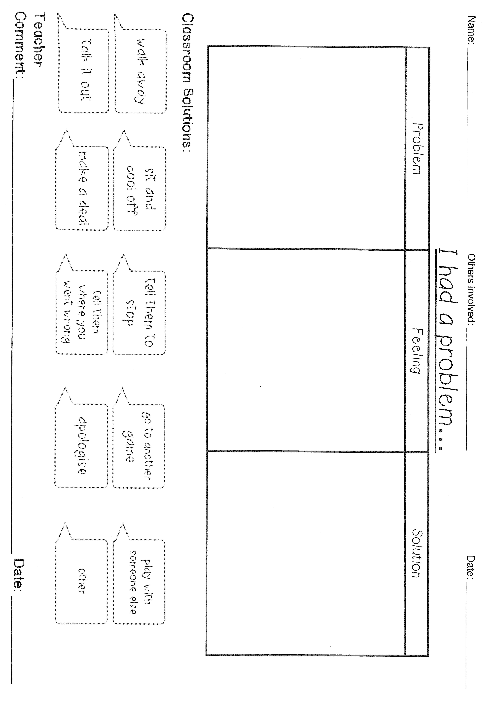

Appendix 2